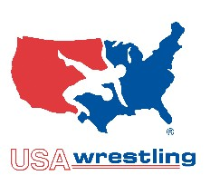
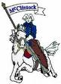
ICHIBAN WRESTLING CLUB
at McClintock High School!
Come learn wrestling, the greatest and oldest sport at McClintock High School. Join the Ichiban wrestling club and learn the art from the McClintock Charger Coaching staff and their Wrestlers. Everyone is welcome boys, girls, beginners and experienced.
Ichiban Wrestling Club will be accepting members who are Elementary school, JR High school, and High school age to join. Wrestlers will learn freestyle, Greco-Roman, & Folk style wrestling skills. Wrestlers will have the opportunity to compete in Tournaments throughout the state on Saturdays hosted by AZ-USA Wrestling. For more information visit the club tab at www.mcclintockwrestling.org
Come wrestle with the best, Ichiban wrestling team. Train like and learn from the Studs in the Charger wrestling room!

Location: McClintock High School Wrestling Room located in gym annex
Start Date: February 26th 2019
Practice Days: Tuesdays & Thursday
Time: 3:00-5:00 High School aged wrestlers
3:30-5:00 JR High aged wrestlers
5:00-6:00 Elementary aged wrestlers
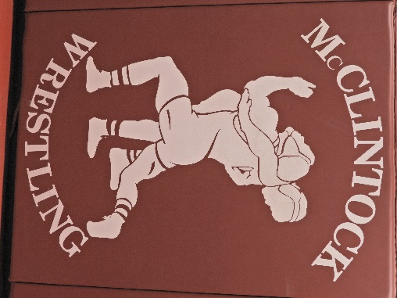
Cost: A 1 time donation to the McClintock wrestling team along with the purchase of a USA wrestling card.

