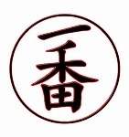
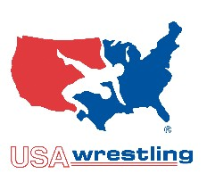
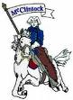
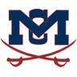
ICHIBAN WRESTLING CLUB
&
McClintock Wrestling Team
Come wrestle with the best, McClintock Wrestling Team/Ichiban Wrestling Club. Train like a Studs in the Chargers wrestling room At McClintock High School!
Come learn wrestling, the greatest and oldest sport at McClintock High School. Join the Ichiban wrestling club and learn the art of wrestling from the McClintock Chargers Coaching staff and Wrestlers. Everyone is welcome boys, girls, beginners, and experienced.
Ichiban Wrestling Club will be accepting members who are Elementary School, JR High School, and High school age to join. Wrestlers will learn freestyle, Greco-Roman, & Folk style wrestling skills. Wrestlers will have the opportunity to compete in Tournaments throughout the state on Saturdays hosted by AZ-USA Wrestling. For more information visit the club tab at www.mcclintockwrestling.org
Coaches available to Meet/Information in the McClintock wrestling room before and after practices
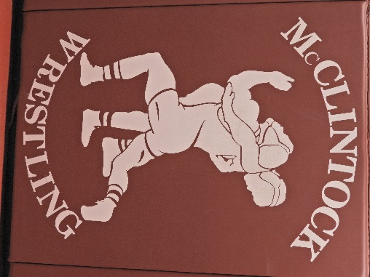
Location: McClintock High School Wrestling Room located in gym annex
Start Date: March 8th 2022
Practice Days: Tuesdays & Thursday
Time: 3:00-5:00 High School aged wrestlers
3:30-5:00 JR High aged wrestlers
4:00-5:00 Elementary aged wrestlers
Cost: A onetime donation to the McClintock wrestling team along with the purchase of a USA wrestling card.

